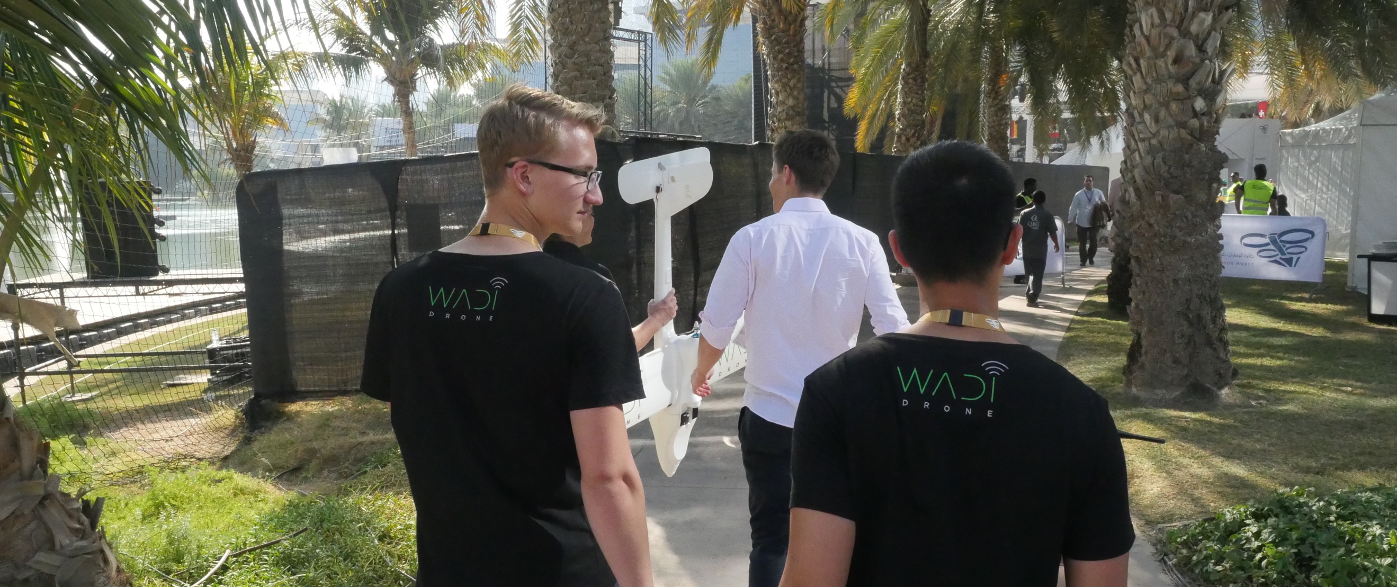

About:

Wadi Drone is a fixed wing data MULE (Mobile Ubiquitous LAN Extension) that automates the collection of camera trap photographs, a critical conservation data. Designed in collaboration with Wadi Wurayah National Park the drone can fly over mountains to camera trap locations and wirelessly download photographs taken by the ground-based camera traps. This technology requires minimal infrastructure and employs off the shelf components, so it is scalable to document animal population sizes and wildlife diversity. Furthermore, with slight modification, the drone can be used to automate the retrieval of any sensor data.

Drone Technical Details

The drone is a costume spec Penguin V2 drone. We fit in the self designed electronics onboard for data transmission and collection and on the camera trap. We use sleepy pi to minimize the power consumbtion of the electronics by turning off Raspberry Pi whenever the electronics are not in use. We have to wireless transmission system, high power and low power. The low power consists of Arduino and Xbee that is always on. It is use to turn Raspberry Pi on when the drone is close. The high power, wifi photo transmission is performed using The raspberry pi on board of the drone and on the camera trap. The drone would circle on top of the camera trap until the photo transmission is complete.

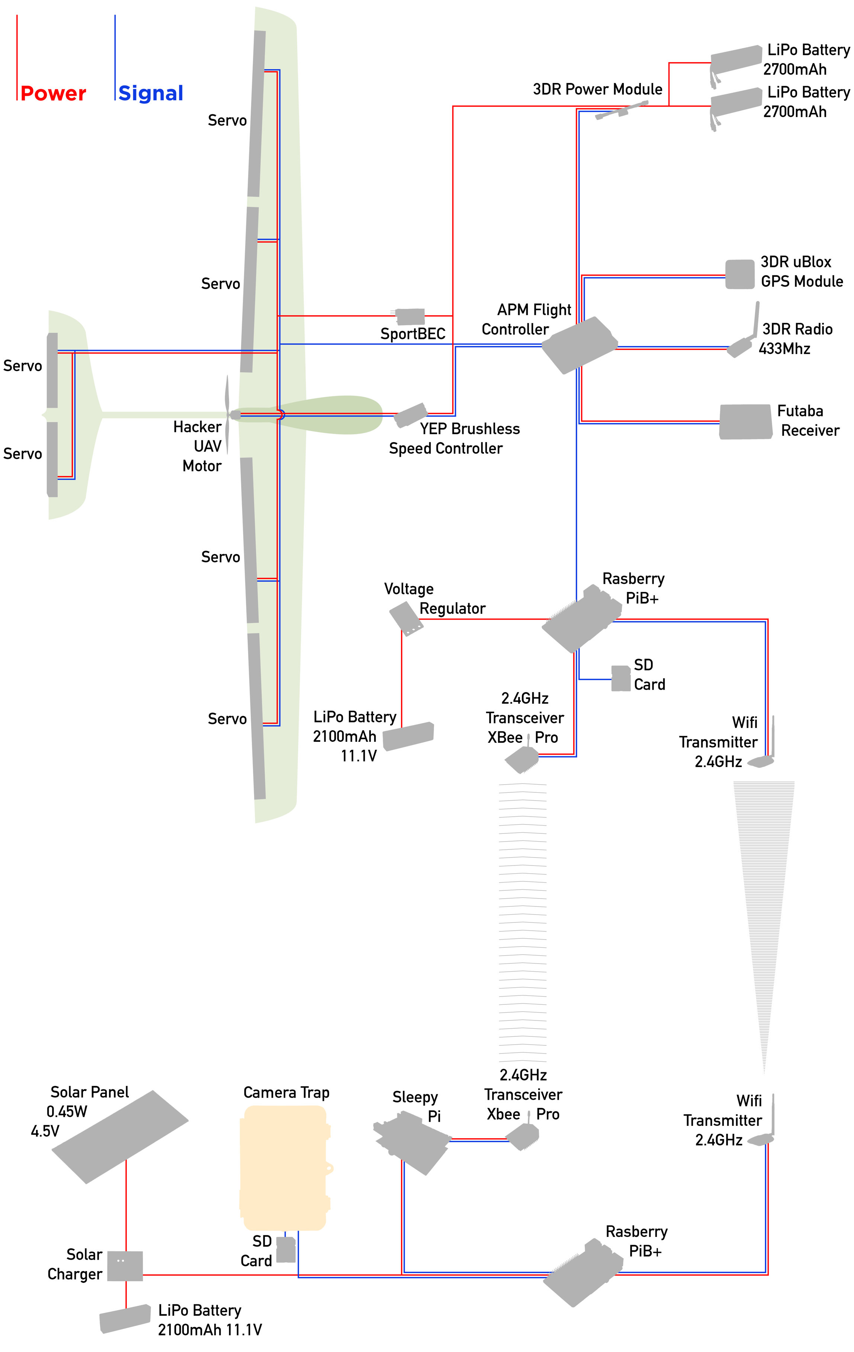

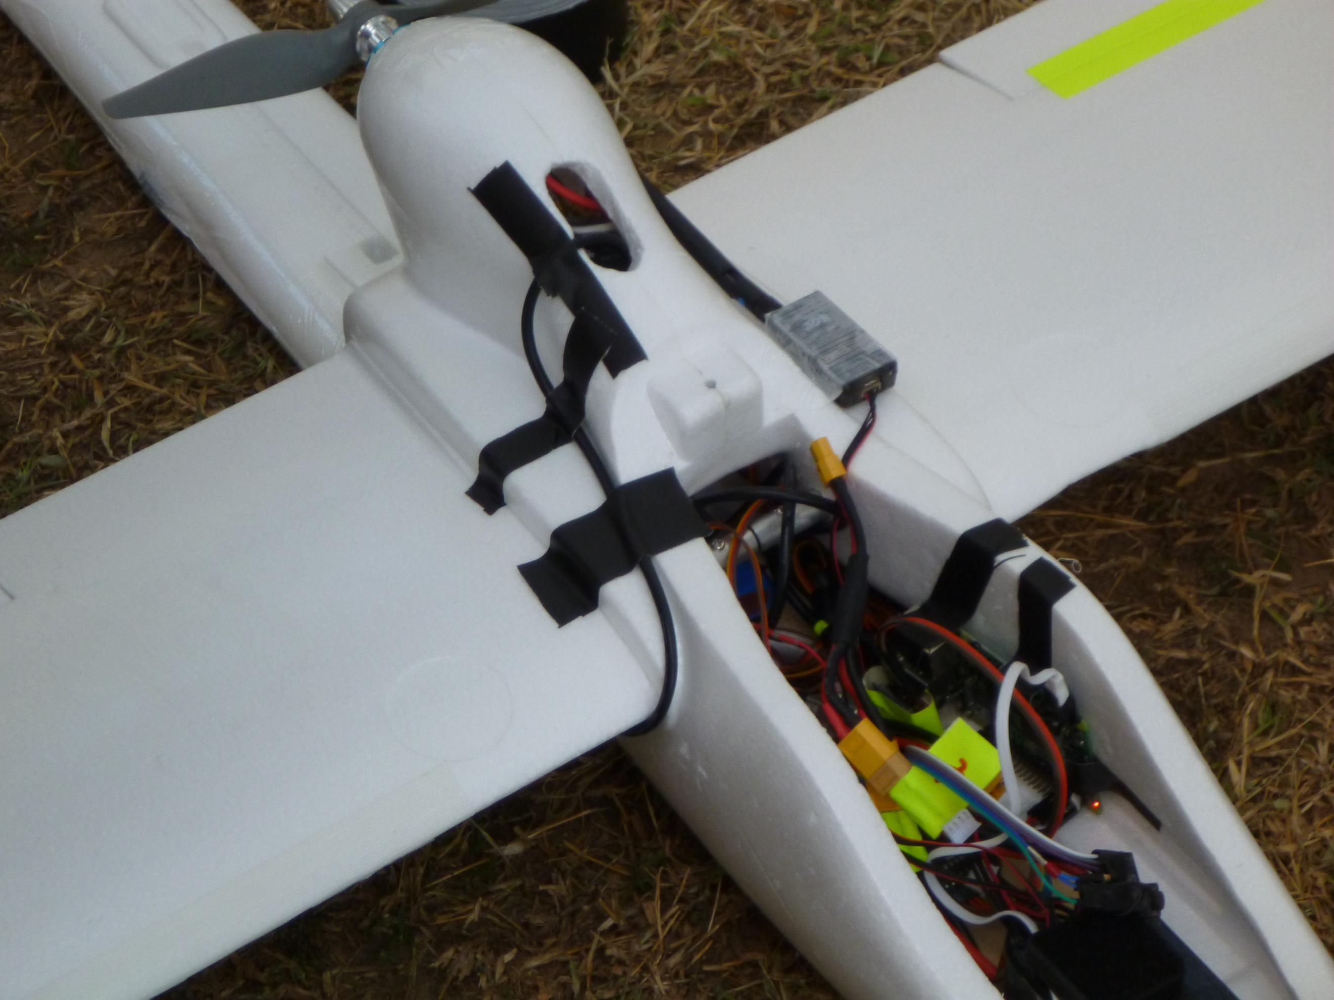

Drones for Good

In February 2015, our team presented Wadi Drone live in front of more than 600 people in the Drones for Good competition. Our team came first in the National category and secured a prize of AED 1,000,000. The experience gave me the chance to improve my public speaking significantly, and led to a handful of other opportunities. Thanks to Wadi Drone, I received an invitation to speak at TEDx in Kiev, Ukraine, at my friend’s former international school.

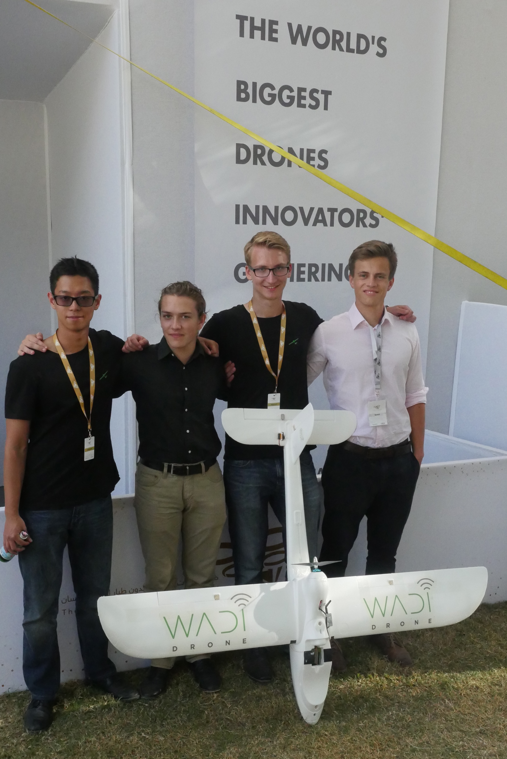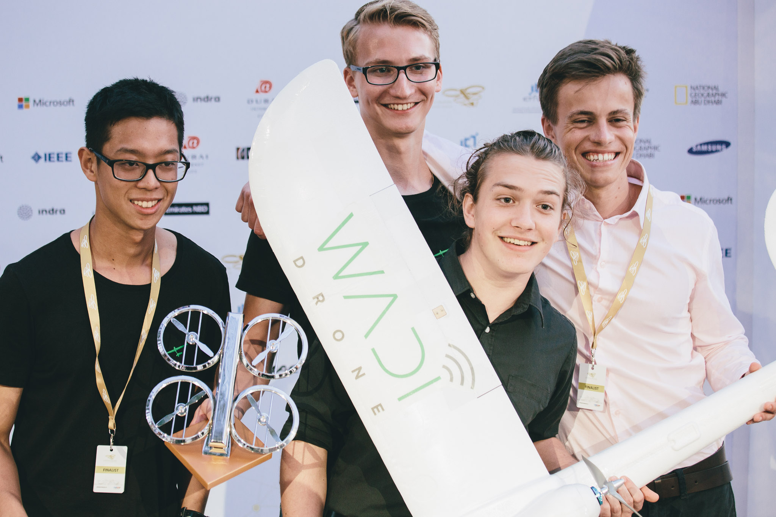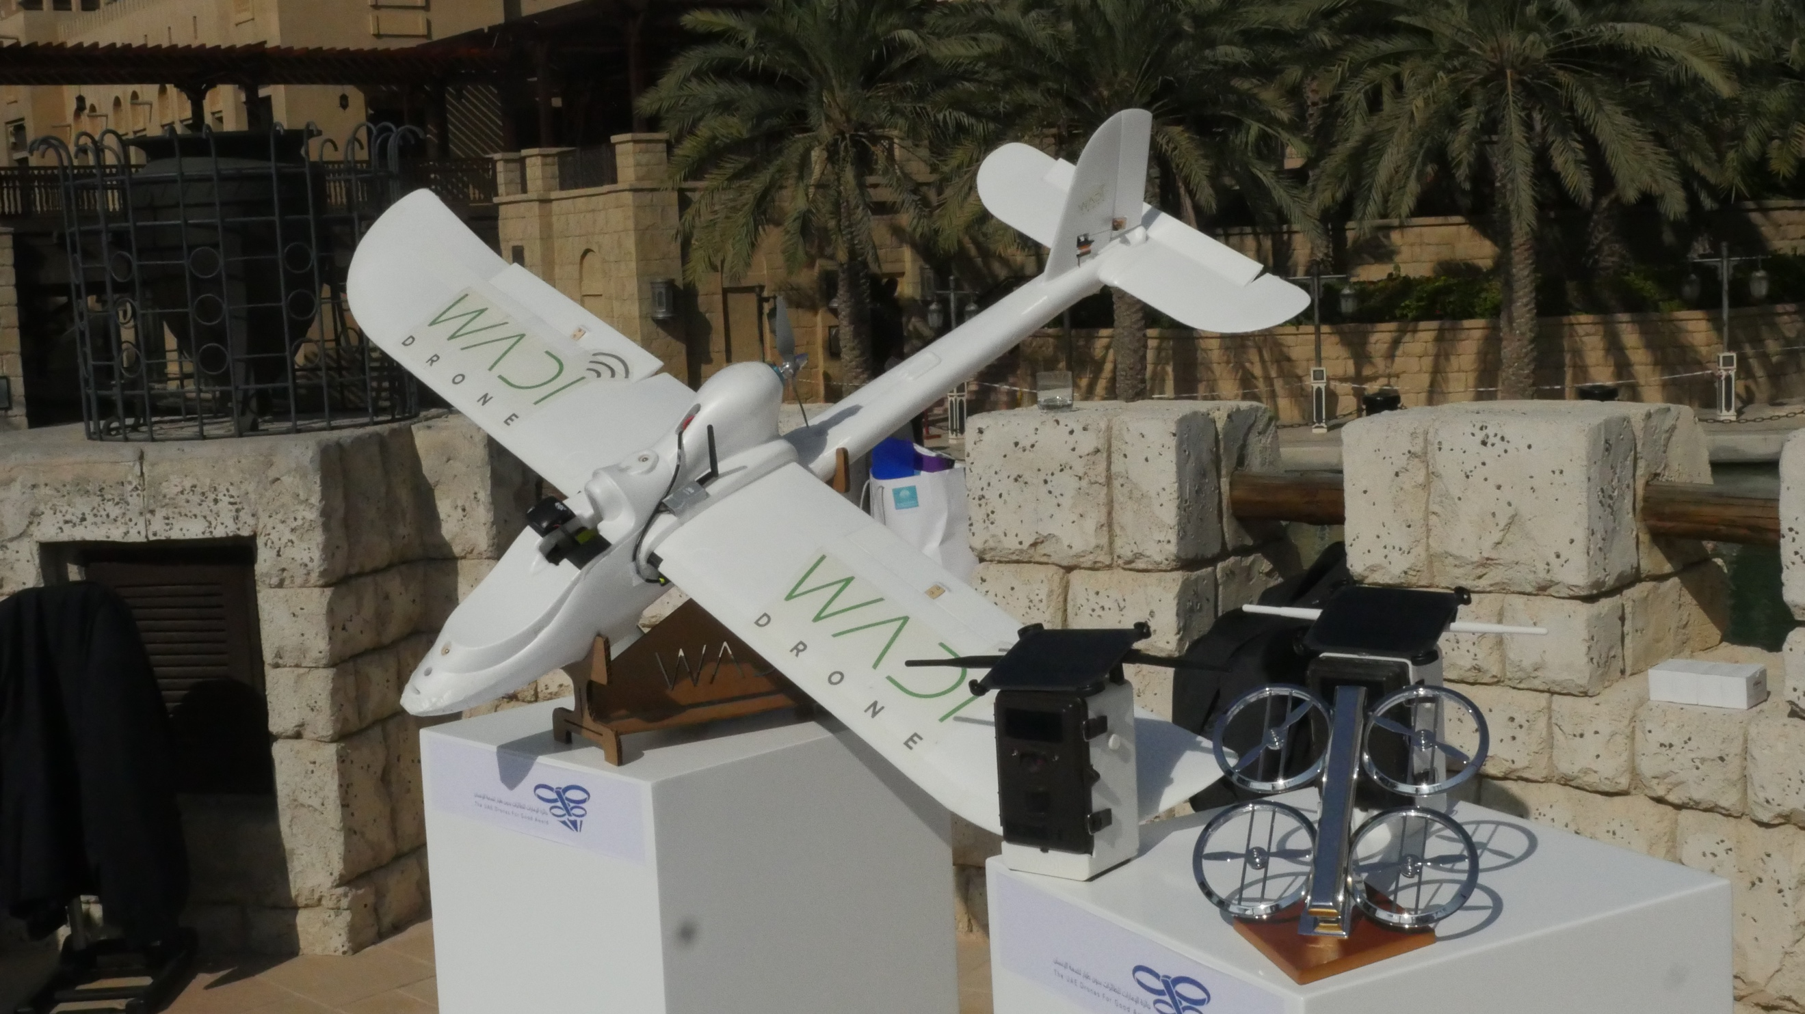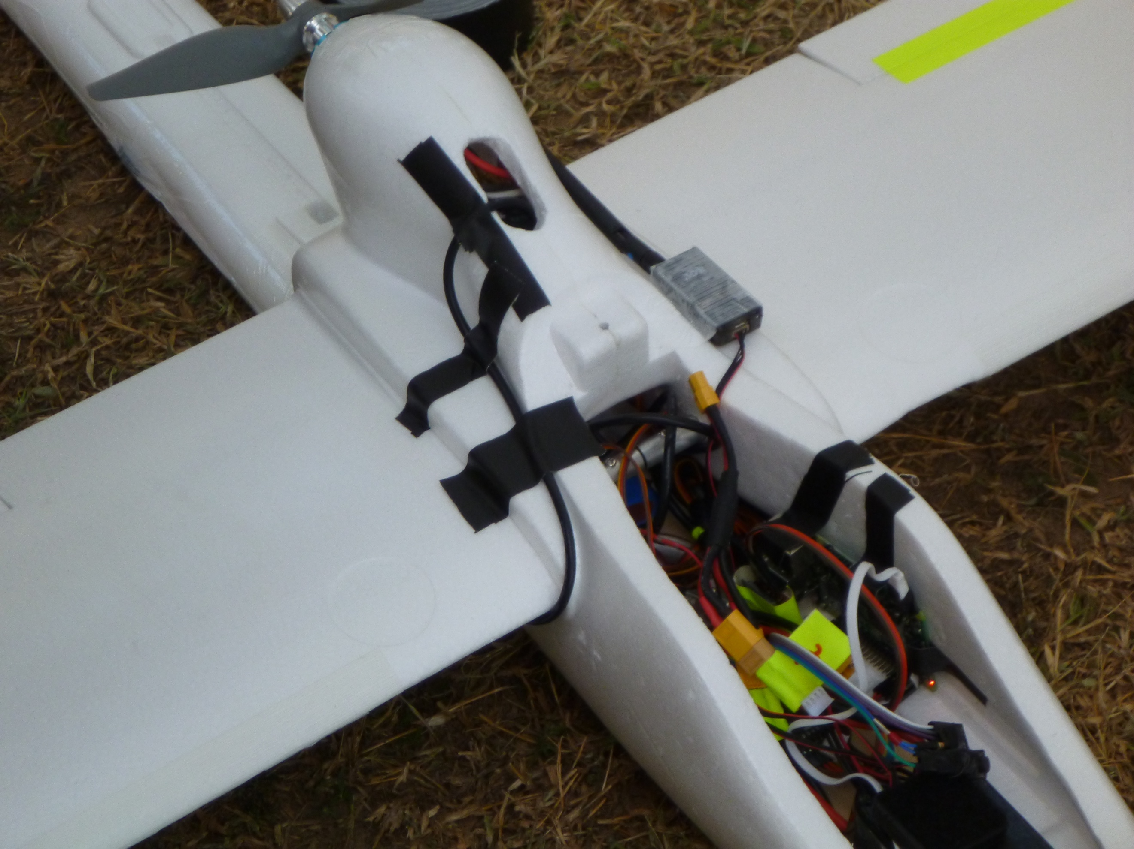

In protected areas worldwide, the use of camera traps involves rangers manually retrieving photos by hiking or driving to each camera at least twice a year. This method is expensive due to the extensive man-hours involved. In the process, rangers become exposed to some combination of difficult terrain, extremely high or low temperature, and wild animals. Furthermore, infrequent access to the camera trap data presents a challenge for researchers as they only receive camera trap data twice a year from each camera. Since the researchers use the data in camera traps to estimate population sizes and to monitor wildlife diversity, infrequent access to the information means that the data is often outdated. Wadi Drone addresses these issues.